**ABOUT US**

 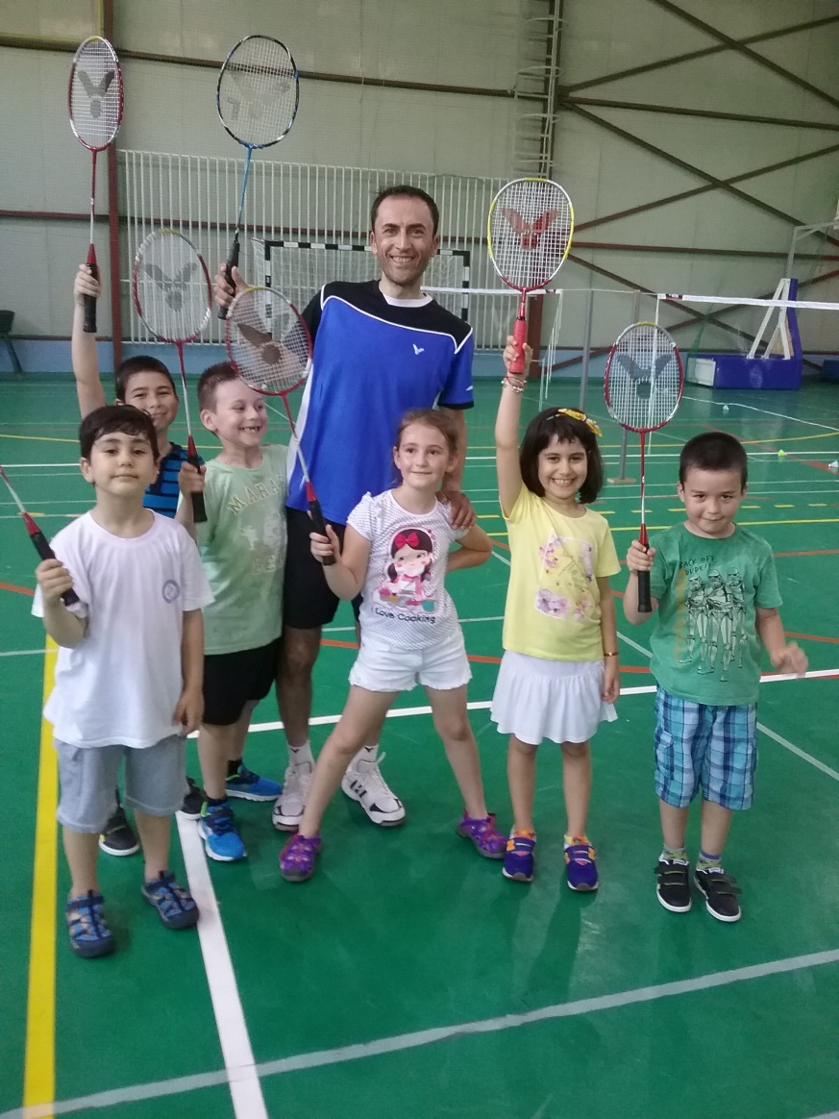

* **Who we are**

We are a united and fun team, full of enthusiasm and eager to share with others our passion and professional experience in the most fastest game in the world - badminton.

* **Our mission**

To help children and juniors of nowadays to do sport, to practice a sport they like and to become better in what they do each day.

* **How we started our journey**

All started when me and my brother begin to practice badminton at the age of 8. We have been training almost every day, until we could participate at professional level, at the age of 15 until almost 25. Now, when we have also children of our own, we play badminton for fun, keep in form by participating in semi-professional and professional competitions for veterans.

* **With whom we want to travel in this journey**

We wish to attract in this journey to a performance in badminton, as much children and juniors as it would be possible, with whom we wish to share our passion, enthusiasm and knowledge about this beautiful and fun sport, badminton – which is not so popular in Romania.

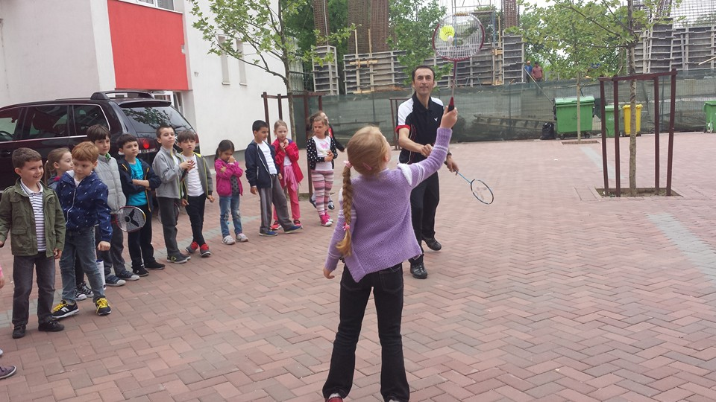

* **Where we are heading to**

One of our objectives is to make badminton more popular in Romania. We wish to expand badminton community and when we will grow, we believe things will change in better and we hope that more badminton facilities (halls and outside courts) will be built by the government all over the country, to promote good and healthy way of life.

Also we will strive to discover talented children and juniors and through their perseverance and dedication, with the help of our guidance and professional experience we believe it would be possible to see one of them on the national and international podiums.

