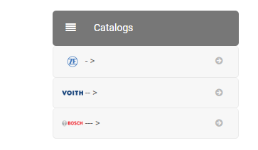

Way be without text but this field is required. That’s why I tied with --> but is not OK



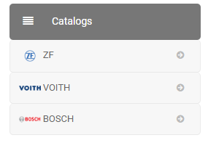

May be some more space between the picture and text

I don’t know how to resolve this issue please for your advice but in this whey is not OK.