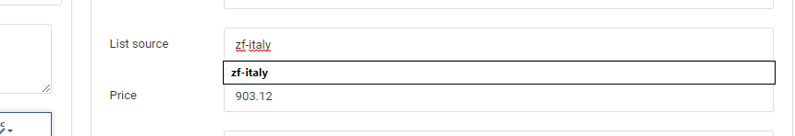

<https://iparts.bg/admin-catalog-products/en-zf/filter-element-1p01181833/edit>